Alien Taxonomy Assignment:
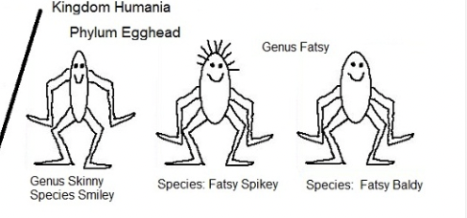
Check List

- Four Groups (minimum)
- Named
- List of Qualitative charactertistics
- List of Quantitative characteristics
- Coloured and Neat

